1. Chemical Composition of Lipids  
 -Lipids are a diverse group of biomolecules that share the common characteristic of being hydrophobic or amphipathic (having both hydrophilic and hydrophobic regions). They include fats, oils, phospholipids, and steroids, among others. The chemical composition of lipids varies depending on the specific type, but generally, they consist of carbon, hydrogen, and oxygen atoms.

-Fats and Oils (Triglycerides):

Fats and oils are composed of molecules called triglycerides, which consist of three fatty acid molecules linked to a glycerol molecule.

-Steroids:

Steroids are a class of lipids characterized by a four-ring structure. he chemical composition of steroids varies depending on the specific compound but generally contains multiple carbon and hydrogen atoms.

2. Building Block of Lipids

- There are two types of lipids. The Glycerol and fatty acids are the basic building blocks of fats (lipids). Fats are the product of the esterification of the trivalent alcohol glycerol with fatty acids of different lengths (between 12 and 20 carbon atoms).

3. Bond of Lipids

-Lipids are characterized by various types of chemical bonds, which contribute to their structure, properties, and biological functions.

Ester Bonds:

Ester bonds are commonly found in lipids such as triglycerides and phospholipids.

Peptide Bonds:

Peptide bonds are not as common in lipids as they are in proteins, but they can be found in certain lipopeptides and lipoproteins.

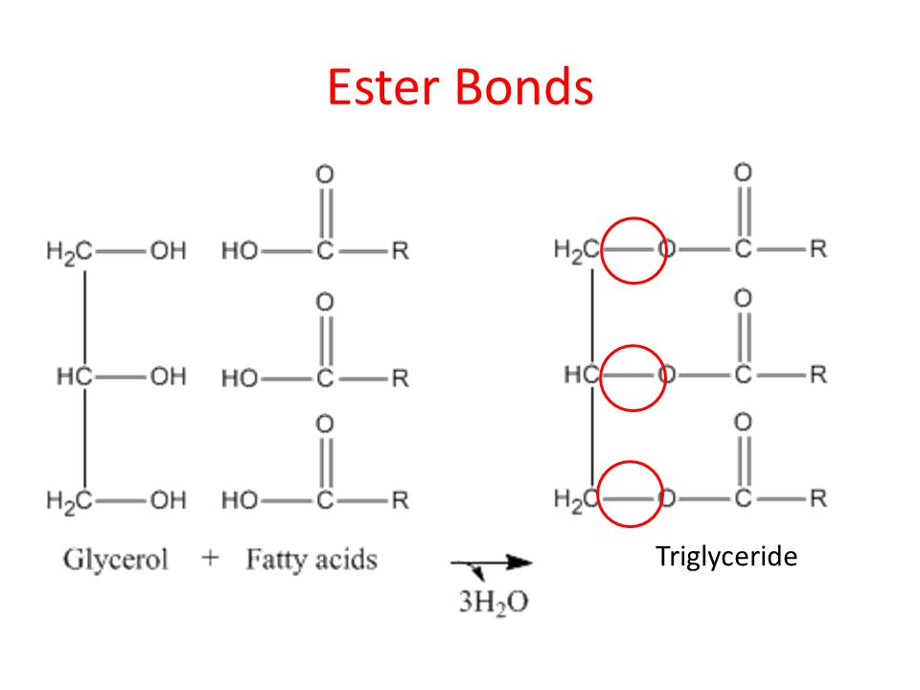

4. Function of Lipids

-Lipids serve a variety of essential functions in living organisms, playing critical roles in cellular structure, energy storage, insulation, signaling, and as components of biological membranes.